Isaiah ‘mapped’ to the Book of Mormon
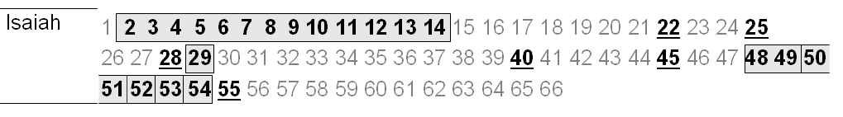
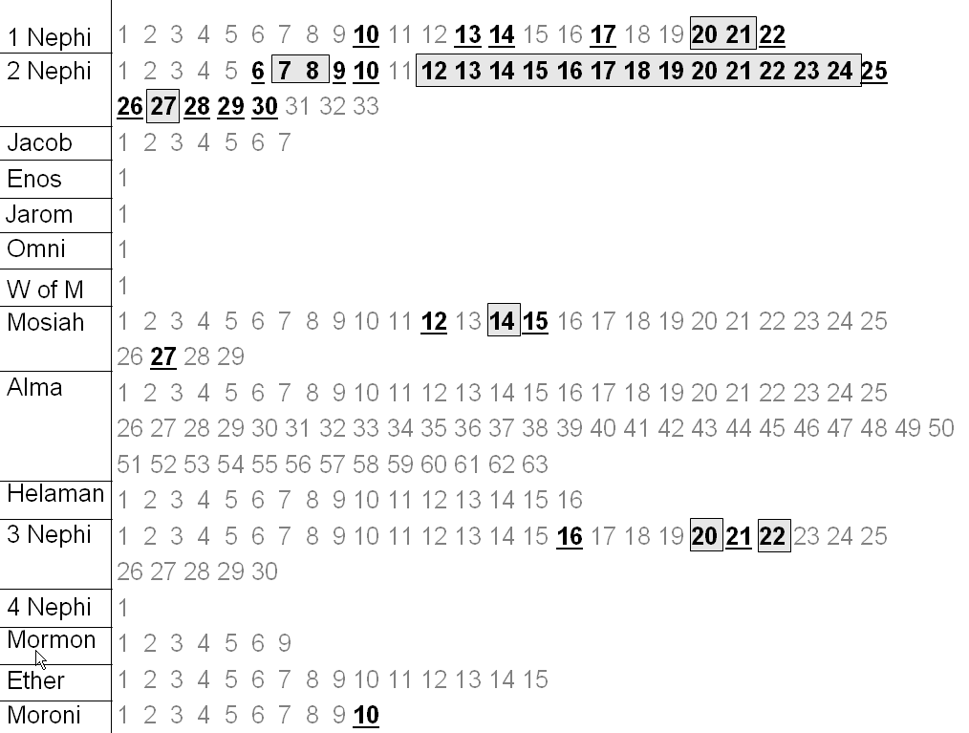

Malachi 3 & 4
Sermon on the Mount at the Temple, Matt. 5-7
There are whole chapters and ‘blocks of chapters’ that match up (the ‘blocks’ in the map) above). But, scattered throughout the Book of Mormon, are other quotes, one or two verses at a time, some from the same Isaiah chapters as the blocks (bolded italics), some from other chapters, and some that are not direct quotes, but paraphrased verses from Isaiah (these are marked with an asterisk *).
Isaiah 2–14 | 2 Nephi 12–24
Isaiah 29 | 2 Nephi 27
Isaiah 48-49 | 1 Nephi 20–21
Isaiah 50–51 | 2 Nephi 7–8
Isaiah 52 | 3 Nephi 20
Isaiah 53 | Mosiah 14
Isaiah 54 | 3 Nephi 22
Isaiah 5:26* | 2 Nephi 29:2
Isaiah 9:12-13 | 2 Nephi 28:32
Isaiah 11:4 | 2 Nephi 30:9
Isaiah 11:5-9 | 2 Nephi 30:11-15
Isaiah 11:11a* | 2 Nephi 25:17a; 29:1b; compare 25:11
Isaiah 22:13* | 2 Nephi 28:7-8
Isaiah 25:12* | 2 Nephi 26:15
Isaiah 28:10, 13* | 2 Nephi 28:30
Isaiah 29:3-4* | 2 Nephi 26:15-16
Isaiah 29:5* | 2 Nephi 26:18
Isaiah 29:6 | 2 Nephi 6:15
Isaiah 29:6-10 | 2 Nephi 27:2-5
Isaiah 29:13 | 2 Nephi 28:9
Isaiah 29:14a* | 1 Nephi 14:7a; 22:8a; 2 Nephi 25:17b; 29:1a
Isaiah 29:15a* | 2 Nephi 28:9a
Isaiah 29:21b* | 2 Nephi 28:16a
Isaiah 40:3* | 1 Nephi 10:8
Isaiah 45:18* | 1 Nephi 17:36
Isaiah 45:23* | Mosiah 27:31
Isaiah 49:22 | 1 Nephi 22:6
Isaiah 49:22* | 1 Nephi 22:8; 2 Nephi 6:6
Isaiah 49:23a* | 1 Nephi 22:8b; 2 Nephi 10:9a
Isaiah 49:23 | 2 Nephi 6:7
Isaiah 49:24-26 | 2 Nephi 6:16-18
Isaiah 52:1a* | Moroni 10:31a
Isaiah 52:1-2 | 2 Nephi 8:24-25
Isaiah 52:7* | 1 Nephi 13:37; Mosiah 15:14-18; 27:37
Isaiah 52:7-10 | Mosiah 12:21-24
Isaiah 52:8-10 | Mosiah 15:29-31; 3 Nephi 16:18-20; 20:32-35
Isaiah 52:10* | 1 Nephi 22:10-11
Isaiah 52:12* | 3 Nephi 21:29
Isaiah 52:13-15* | 3 Nephi 21:8 -10
Isaiah 53:8, 10* | Mosiah 15:10-11
Isaiah 54:2b* | Moroni 10:31a
Isaiah 55:1* | 2 Nephi 26:25
Isaiah 55:1-2 | 2 Nephi 9:50 -51

Source: Unlocking Isaiah in the Book of Mormon, Victor Ludlow, Deseret Book, 2003. Also, Book of Mormon Reference Companion, Dennis Largey, Editor, Deseret Book, 2003

