City Lights as DRLs
- Mod Wire Assembly
(1) VW Fuse Holder, PN 1J0-937-530-B
(1) VW Wire/Contacts for Fuse Holder, PN 000-979-135, Comes in package of 5
5A Fuse
18 Gauge Wire
(2) #16-14 Butt Splice
(1) 1N5400 2A diode
(3) 22-18 Insulated Wire Splice
(2) Insulated Female Spade Terminal
(1) Insulated Male Spade Terminal
Heat Shrink Tubing
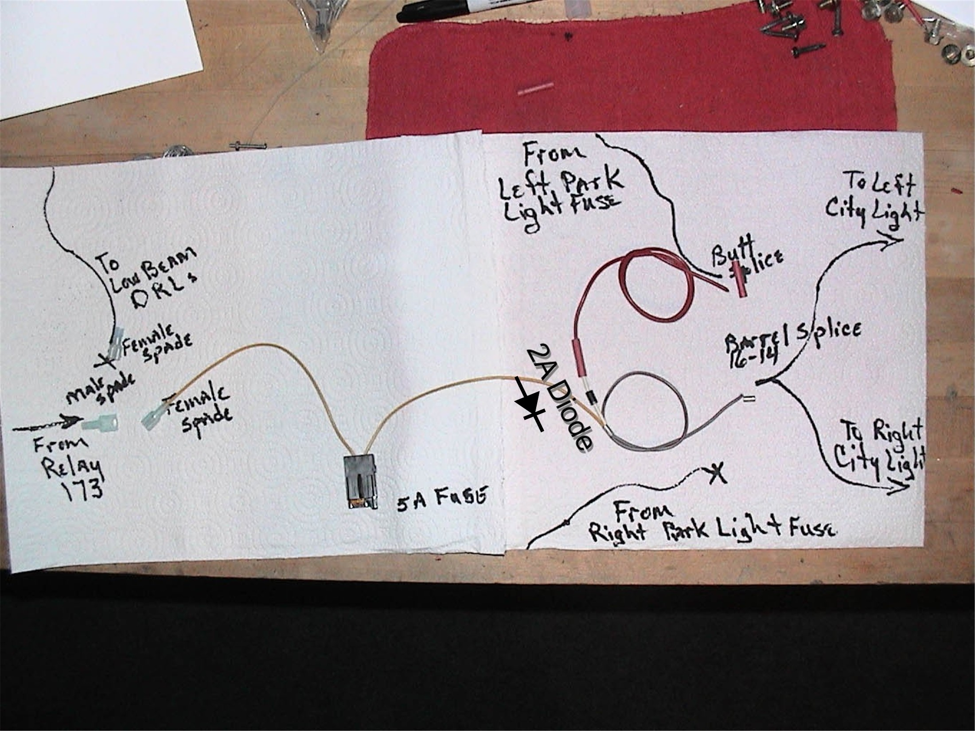
- Assemble the proper tools.
Terminal Crimpers
Diagonal Cutters
Wire Strippers
#20 and #25 Torx Bits and Driver
10mm Socket or Nut Driver
Sharp Knife or Razor Blade
- Remove the lower dash trim pieces under the steering column. There are two plastic pieces and one metal piece. The left plastic trim panel has two screws at the bottom and unclips at the top. The right trim panel has two screws along the bottom and unclips at the top and along the center dash.
- Remove the plastic cover between the pedal area and the under dash area. The cover snaps into the support at the along the bottom of the dash and fits into slots at the firewall.
- Remove the screw holding the Scan Tool connector to the support and move the connector to the left out of the way.
The relay panel should be accessible as shown in figure 1.
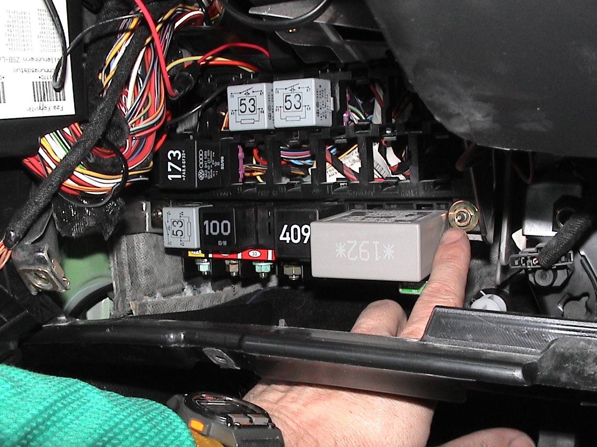
Figure 1. Lower and Auxiliary Relay Panels.

- Remove the 10mm nuts at each end of the relay panel (fig 1.) and carefully pull the panels toward you and to the right. This will allow the necessary access behind the panels as shown in figure 2.
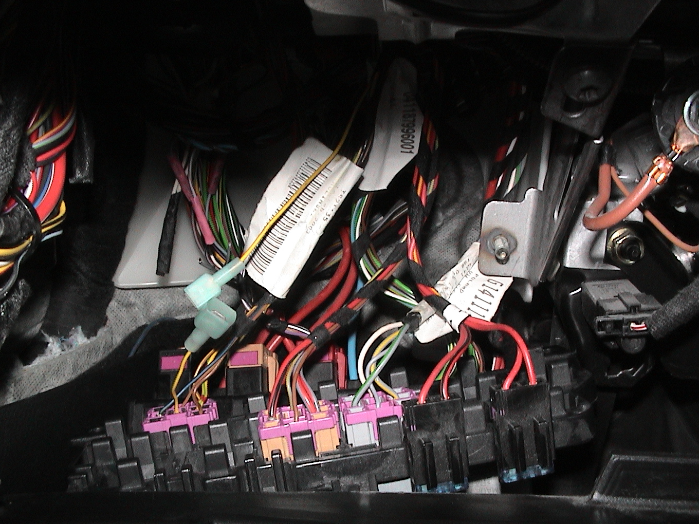
Figure 2. Wire from Change-over Relay to Lights is Cut and Terminals Installed.
- Find the Yellow/Green wire in the back of the DRL Change-over Relay (173) connector at position 5. There will be another wire the same color at position 2, do NOT cut that one. Cut the wire at position 5 about 4” behind the connector. Carefully pull both ends out of the harness wrap. Install the insulated male spade terminal on the wire from the relay connector. Install the insulated female spade terminal on the end of the wire that goes into the harness wrap. This terminal will be left insulated and unconnected. If you ever want to de-mod the car, remove the Mod Wire Assembly and reconnect this wire via the terminals. Figure 2 shows the wire with the terminals installed.
- Install the Mod Wire Assembly by sliding the relay socket onto the first position to the right of the top center, see figure 3. If there is already a fuse there the new socket will slide onto that socket.
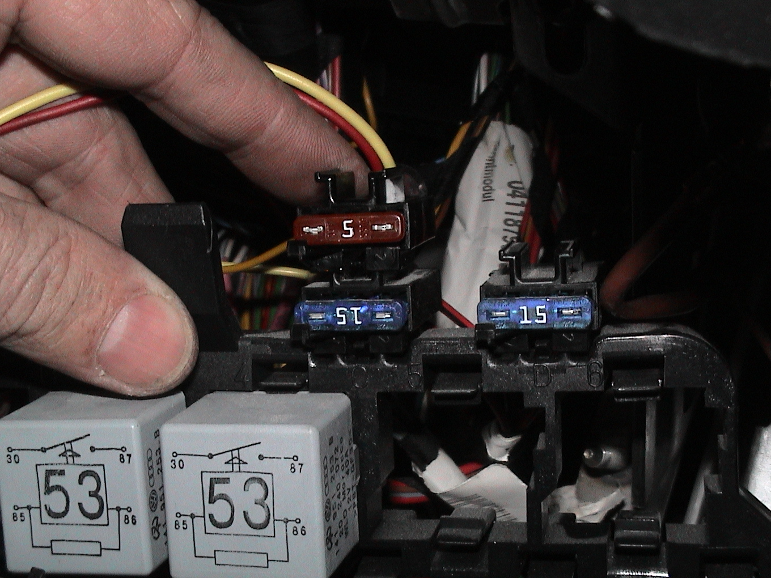
Figure 3. Install Wire Assembly Fuse Socket at Top, Just Right of Center.
- Plug the insulated male spade terminal from the DRL Chang-over Relay to the insulated female terminal on the fuse socket lead.
- Find the wire bundle that goes from high in the dash area out through the firewall just above the pedals. Remove the cloth tape CAREFULLY from this bundle with a sharp knife or razor in the area directly behind the relay panels. The bundle with the tape removed is shown in figure 4.
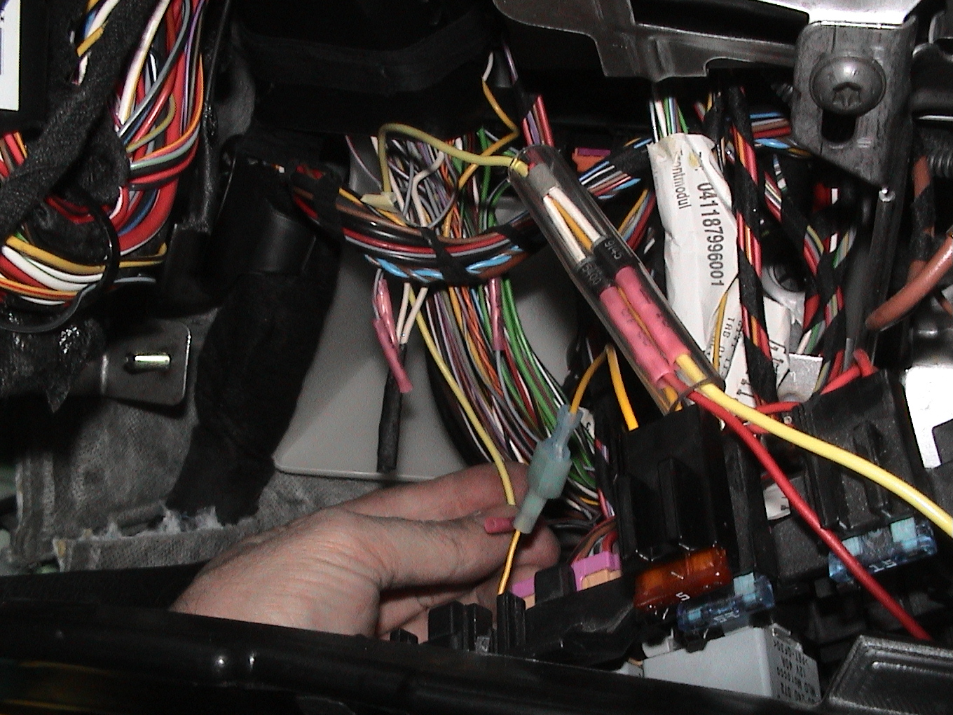
Figure 4. Wire Bundle with Tape Removed for Access to the Park Light Wires.
- There are two circuits for the Park Lights, one for left and one for the right. Each circuit powers the City Lights, Side Markers, Tails, and a wire to the Control Module in the dash for the respective side of the car. The wires for the left side are Grey/Black and the right are Grey/Red. There are four wires of each color combination in this bundle and the wire to the City Lights is the one needed. Two of the four can be eliminated by size. The wire to the Tail is 1.0mm² and the wire to the Control Module is 0.35mm² but the wires to the City Lights and the Side Markers are both 0.5mm² and cannot be isolated. Find the Grey/Black wires that are the same size, 0.5mm², and cut one of them. Turn the lights on and see if the left City Light or Side Marker is out. If the Side Marker is out, splice the wire back together and cut the other one. Put electrical tape on the end that goes toward the fuse panel. Do the same thing for the Grey/Red wires of the right side except do not tape the end that goes toward the fuse panel.
- You should have the end of the Grey/Black wire that goes to the left City Light and the end of the Grey/Red wire that goes to the right City Light. Be careful with the strippers in this area so that other wires aren’t damaged. Strip the ends of the wires and twist them together as shown in figure 5.
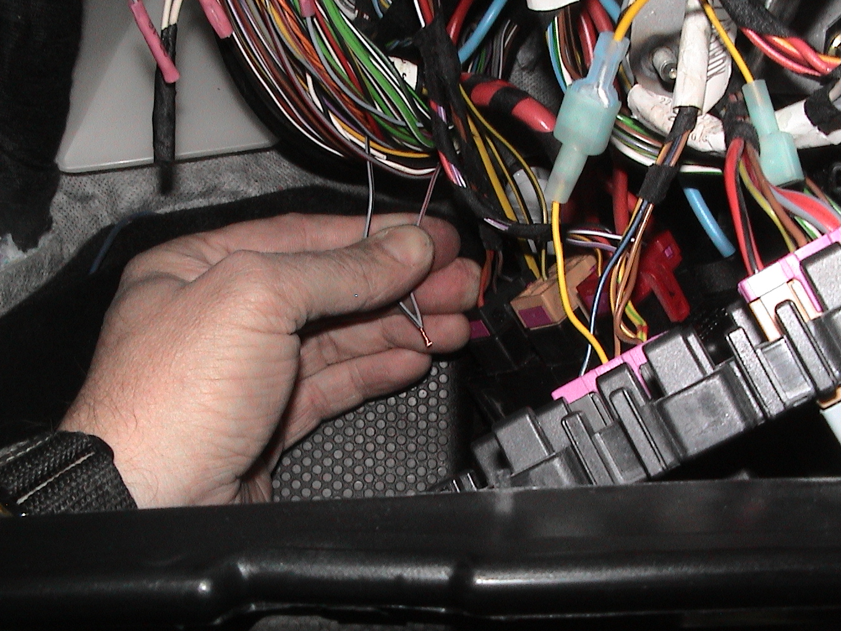
Figure 5. Left and Right City Light Wires Stripped and Twisted Together.
- Be careful with the crimpers in this area so that other wires aren’t damaged. Route the wire of Mod Wire Assembly (the one without the diode) logically to the City Light wires as shown in figure 4 (Yellow wire in figure 4). Slide some heat shrink over the wire then splice the wire of the Mod Wiring Assembly to the two City Light wires with a #16-14 butt splice. Shrink the tubing to insulate the splice
- Route the Mod Wiring Assembly wire (the one with the diode) to the free end of the Grey/Red wire end. Splice the wires together using 22-18 wire splice.
- Carefully form the wire bundle back into shape and secure it with wire ties as shown in figure 6. trim the ends of the wire ties.
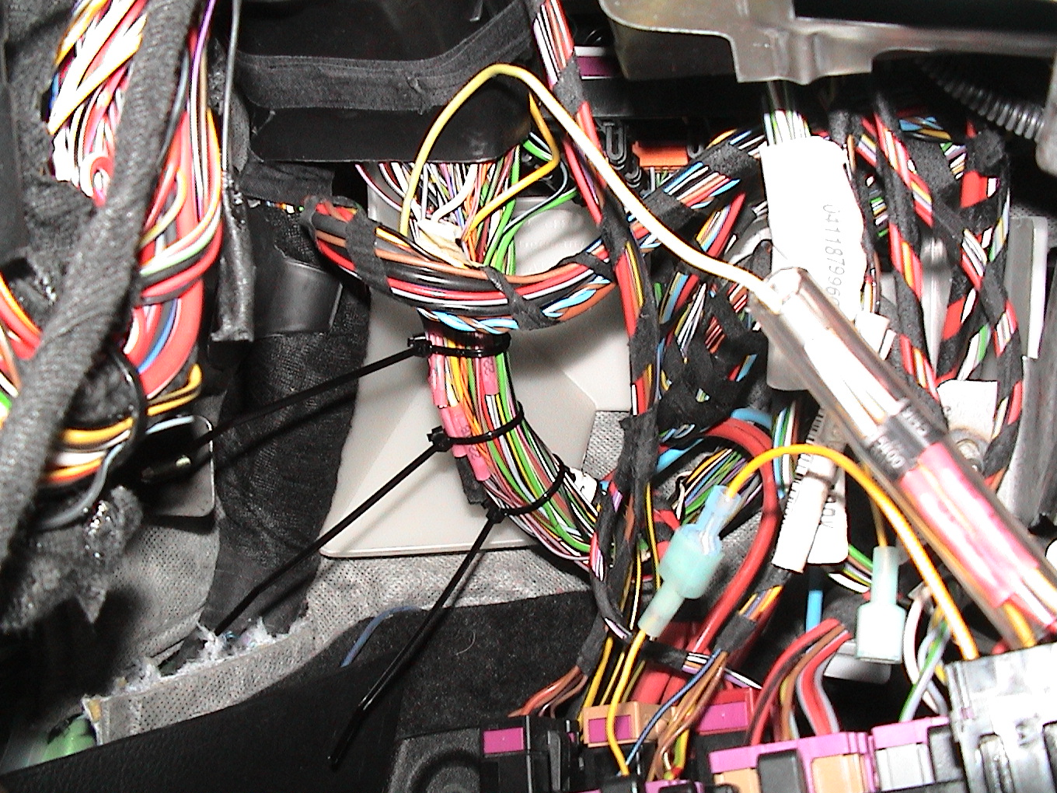
Figure 6. Wire Bundle Secured with Wire Ties.
- Carefully replace the relay. Make sure that no wire behind the relay panels are kinked or pinched.
- Block a wheel, turn on the Ignition, release the Parking Brake and verify that your City Lights are on as DRLs. Turn on the Light Switch and verify that the City Lights are still on with the Park Lights.
- Replace the Scan Tool connector.
- Install the plastic cover under the dash over the brake and clutch pedals.
- Replace the trim.

