Catalog of AO Series 10 Microscope Illuminators
Model | Photo | Bulb | Note
#1038 | 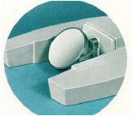 |  | Mirror and Fork Assembly
#1034 | 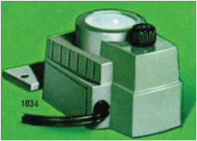 | GE #15 S11/102, 115V 15Watt  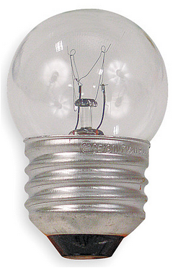 | “Inexpensive On-Base illuminator” designed specifically for monocular models. Contains a reflector, blue glass filter, and spherical condensing lens.
#1037 | 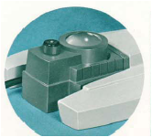 | GE #15 S11/102, 115V 15Watt | “Inexpensive On-Base illuminator” designed specifically for binocular models. Contains a reflector, blue glass filter, and spherical condensing lens. Similar in construction to #1034 except containing a more highly corrected aspheric condenser yielding greater intensity.
#1036 | 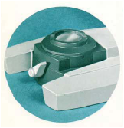 | GE #1460, 6.5V 2.75A  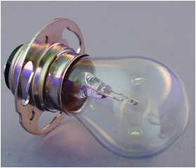 | “High Intensity Illuminator #1036 for advanced laboratory work, photomicrography, and viewing screen use. “Provides essentially Koehler Illumination”
#1036A | 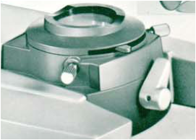 | GE #1460, 6.5V 2.75A | “High Intensity Illuminator for advanced laboratory work, darkfield, photomicrography, and viewing screen use. Centerable iris diaphragm. Swing-in/swing-out 10% neutral density filter.
#1031 | 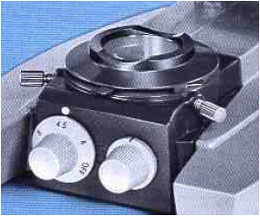 | 6V 20Watt Tungsten Halogen, Philips #7388 (or equivalent), with G4 base  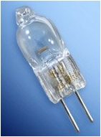 | High intensity illuminator; offers more light than previously available, solid state controls. Halogen lamp assures greater efficiency and truer color rendition; exceptionally long lamp life. Illuminator includes 15% swing-in/swing-out neutral density filter. Centerable iris field diaphragm for Koehler illumination.

