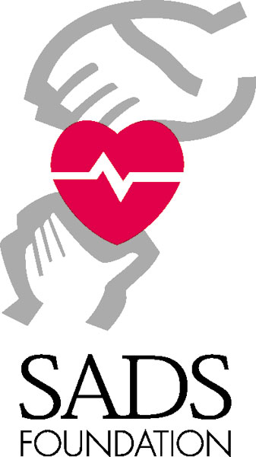
Independent Fundraising Event Proposal

Thank you for your interest in organizing a special event to benefit the Sudden Arrhythmia Death Syndromes (SADS) Foundation! Your efforts help us save lives by educating doctors, communities and patients about hereditary heart rhythm disorders.
You can save this MS Word document and either complete it on your computer or by hand. Please submit your completed proposal to the Foundation before your event. You may mail it to the address below, fax it to 801/531-0945 or email it to sarah@sads.org.
We ask for this information for several reasons: 1) so that we can better help you raise money for the SADS Foundation, 2) so that one clever volunteer idea can be shared with other interested volunteers, avoiding wheel reinvention, and 3) because the SADS Foundation’s nonprofit status and reputation are necessary to the work that we do, and some fund raisers have legal complications.

General Information
Name of Group or Organization Planning Event:

Name of Individual Responsible:
Address:
Email:
Phone numbers:
Date of Event: Location:
Please briefly describe the event you are proposing:

Are licenses or permits required for this event? □ Yes □No

Please note that using public streets or parks, holding raffles or lotteries, and serving alcohol are regulated in many communities. The SADS Foundation staff may need to apply for the appropriate permits on your behalf.

Publicizing your event
Which of the following will you use to publicize your event and when?

□ Posters/Flyers/Signs

□ Newspaper/Magazine Advertising

□ Radio/TV PSA’s

□ Media Interviews/Stories

□ Other

Financial Information
Estimated gross revenue from event $

Estimated Expenses $

Estimated Donation to the SADS Foundation $

Do you intend to □ Donate the event expenses or □ Cover them from the proceeds?
(The SADS Foundation does not usually reimburse volunteers for event costs. If you believe covering event expenses will be a challenge and want to discuss possible solutions with SADS Foundation staff, please call us early in your event planning at 800/786-7723.)

What types of expenses do you expect?

Will other charitable organizations benefit from this event? □ Yes □No

If so, please list:

How will donations be divided between organizations?

Donor Recognition
We would like to acknowledge your hard work on behalf of the SADS Foundation in our newsletter and at conferences. How would you like to be named? And would you send us photos of your event? __________________________________________________

Sudden Arrhythmia Death Syndromes Foundation

Fund Raising Guidelines

The Sudden Arrhythmia Death Syndromes (SADS) Foundation is responsible for all fund raising and awareness events organized on behalf of the Foundation. The SADS Foundation’s nonprofit status and reputation of integrity depend on fund raising events complying with the following guidelines.

- The SADS Foundation name and logo must be protected and used in a manner consistent with the positive and professional image of the organization. The SADS Foundation name and logos will not be used without written permission from SADS Foundation staff. When the name and logos are used, all promotional and printed material will be reviewed and approved by SADS Foundation staff.

- Event print and promotional materials must clearly state that the SADS Foundation will benefit from the event, for example:

“All proceeds of this event will go to the Sudden Arrhythmia Death Syndromes Foundation.”
or
“ 50% of the ticket price will be donated to the SADS Foundation.”

- By naming the SADS Foundation as a beneficiary of your event, you agree to donate the stated portion of the net proceeds of your event to SADS within a month of the event’s conclusion. Once your event is approved, SADS Foundation relies on your event to generate funds for its life-saving programs.

- The sponsoring organization, group, or individual agrees to handle all monetary transactions for the event. Checks made payable to the SADS Foundation or credit card information received in conjunction with the event will be mailed to the SADS Foundation for processing. Event expenses will be reimbursed by the SADS Foundation as agreed to in writing prior to the event.

- The SADS Foundation is not responsible for any financial losses incurred in conjunction with any event. Furthermore, the sponsoring organization or group agrees to underwrite all the costs of the event and to secure such underwriting. The SADS Foundation shall incur no costs unless otherwise agreed in writing prior to this event.

- The SADS Foundation will not be party to any liability coverage without prior knowledge and/or approval, and will accept no legal responsibility. The SADS Foundation cannot be held liable for any damage, risk, injury, or otherwise, in connection with this event.

- The group or organization organizing the event is responsible for complying with all applicable local, state, and federal laws and regulations and notifying SADS Foundation staff of any necessary licenses or permits.

- Event participants are responsible for determining the eligibility of their donations for income tax exemption in accordance with US Income tax code. SADS Foundation staff will provide information useful in making this determination as requested. Depending on donation circumstances, not all donations and ticket receipts are tax-deductible.

- The final use of all SADS Foundation resources and donations will be determined by the SADS Foundation.

Independent Fundraising Event Agreement

Based on the information provided in this application and SADS Foundation fundraising policies, the SADS Foundation and the undersigned understand and mutually agree to the following:

- Event information, including place and time
- Logo/promotion clause

On behalf of the group or organization holding the event:

Signed:

Date:

On behalf of the Sudden Arrhythmia Death Syndromes Foundation:

Signed:

Date:

